Linux Commands Day 3
Top - The top command is used to monitor real-time system performance, including CPU usage, memory usage, and running processes.
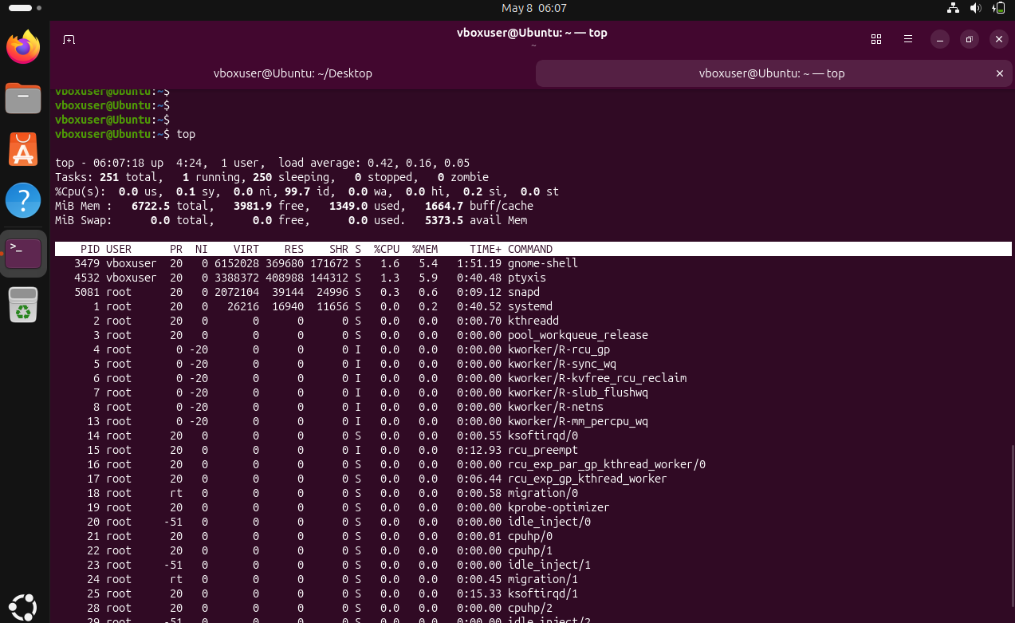
ps -ef is a Linux command used to display all running processes in the system in a full-format listing.
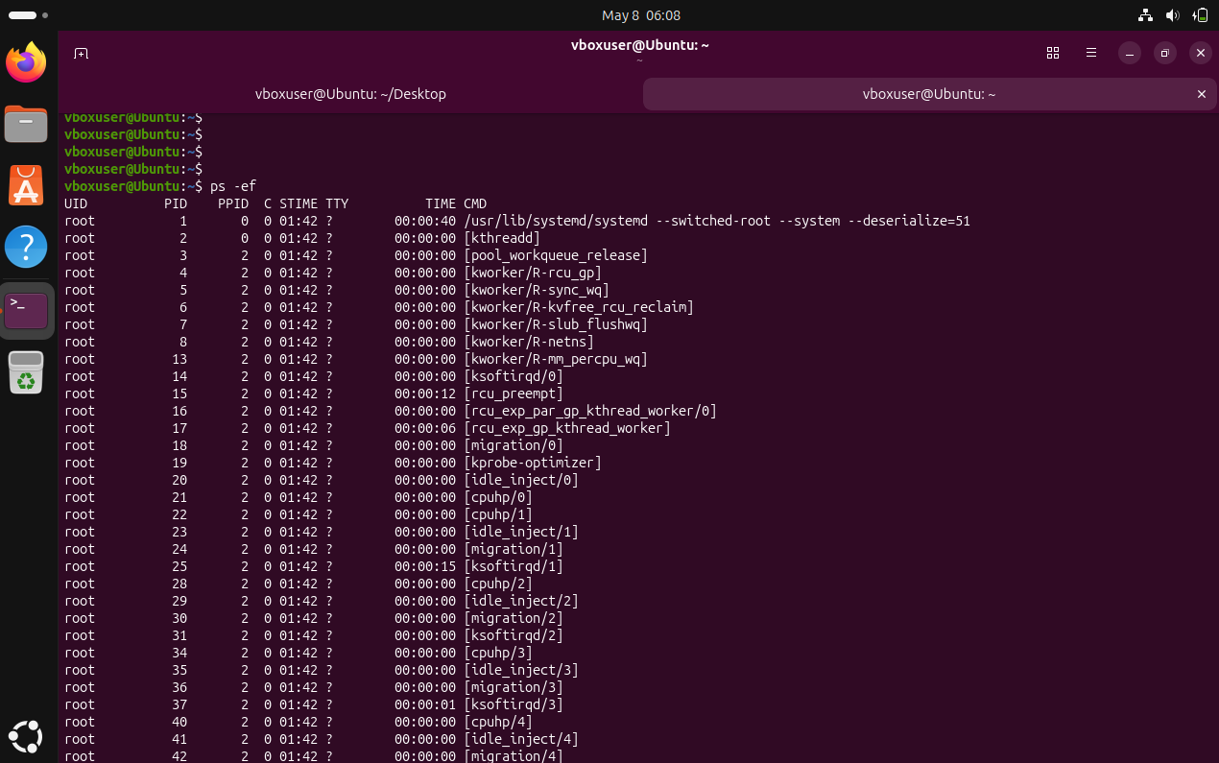
ps -ef | grep tomcat - This command is used to check whether Tomcat is running and to filter its process details from all system processes.
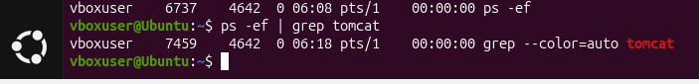
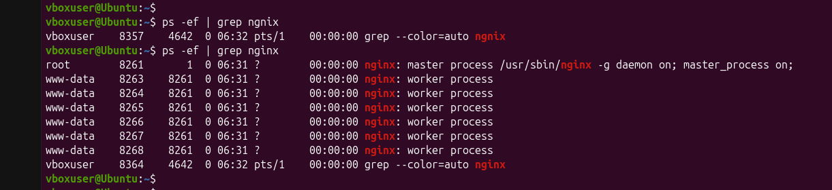
kill -9 = forcefully terminate a process immediately without waiting
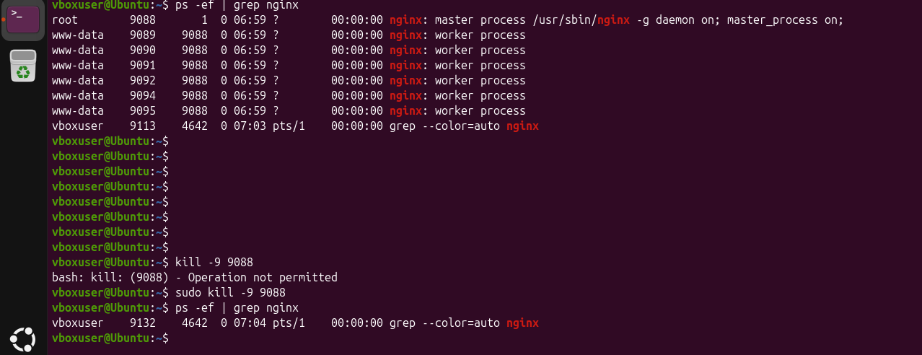
tar -cvf is used in Linux to create an archive file (.tar) from multiple files or directories.
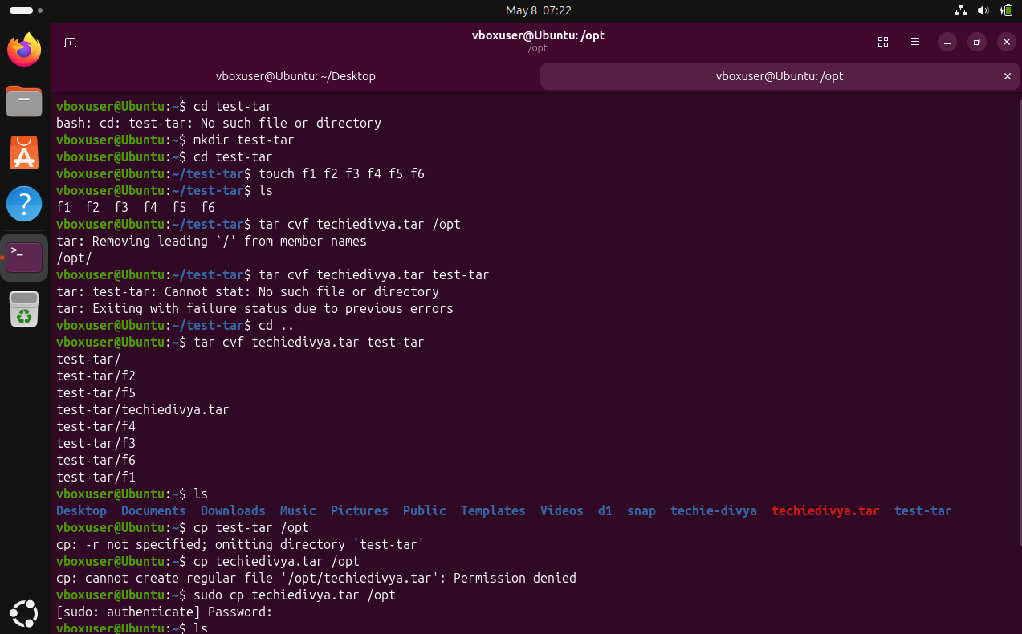
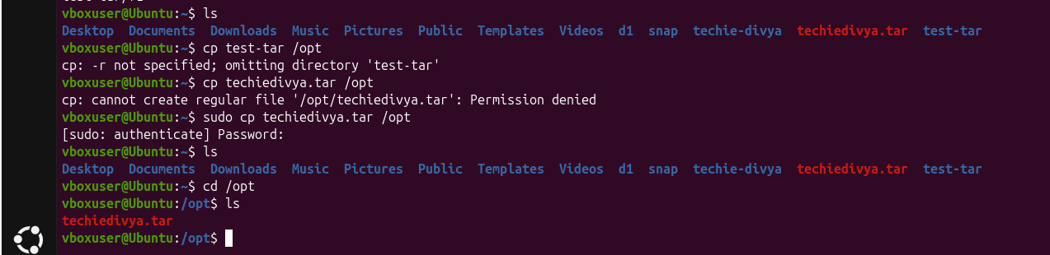
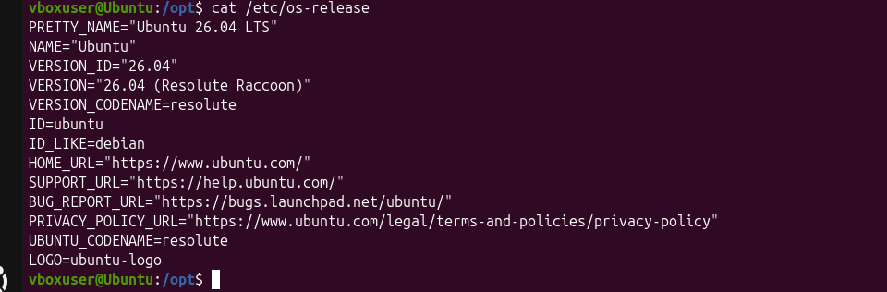
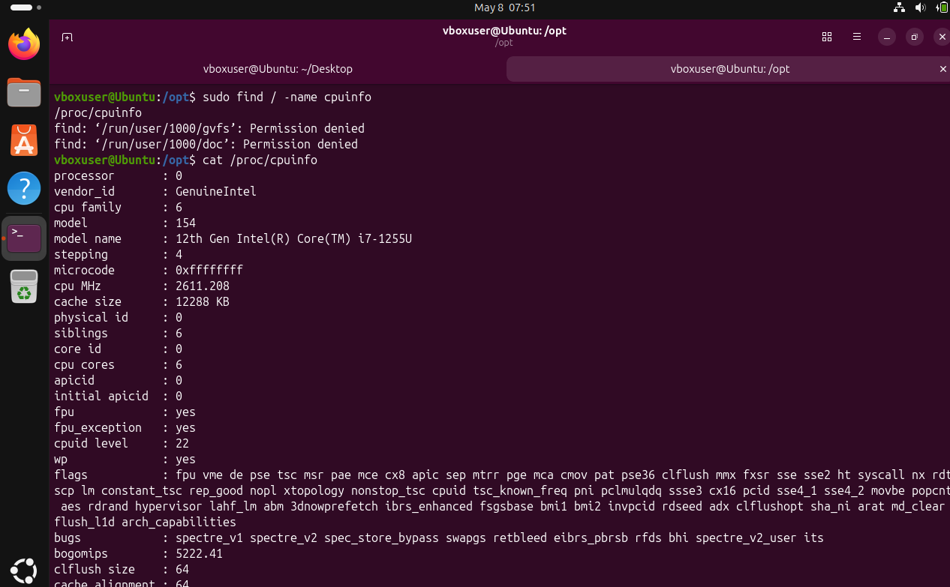
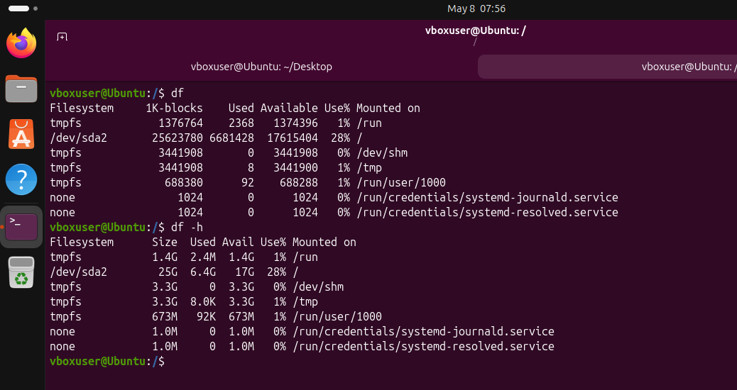
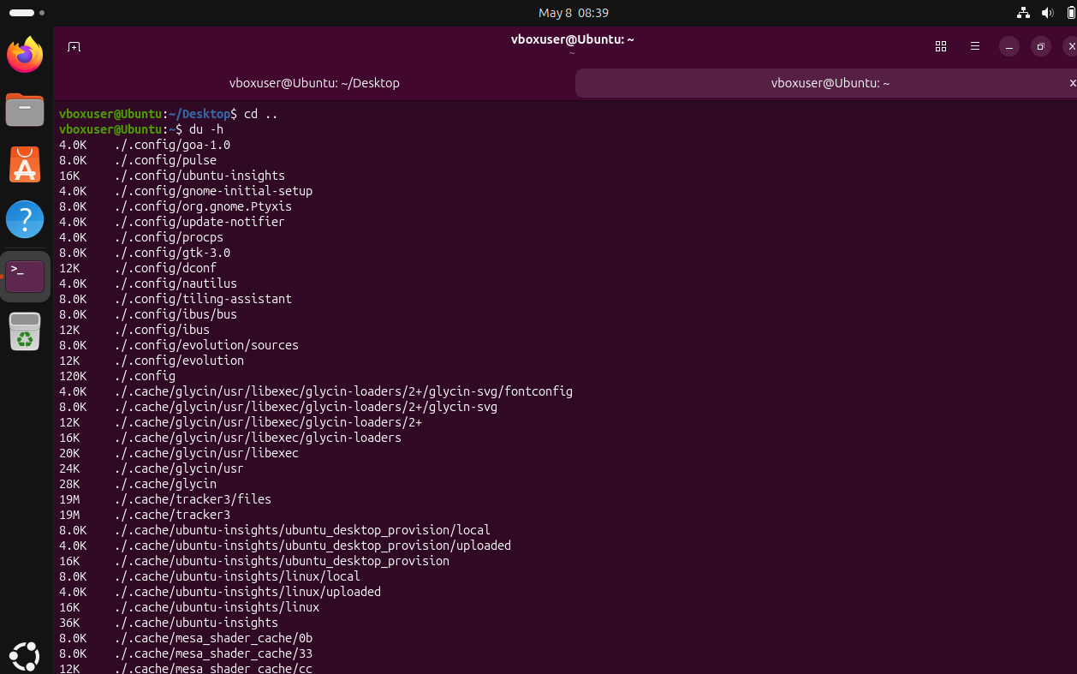
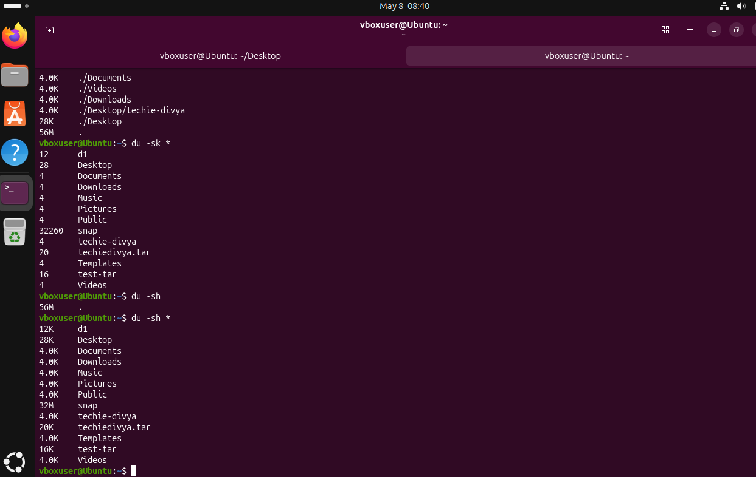
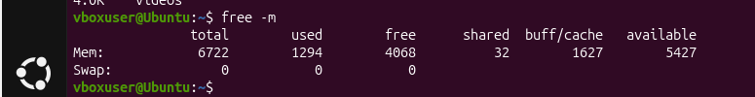
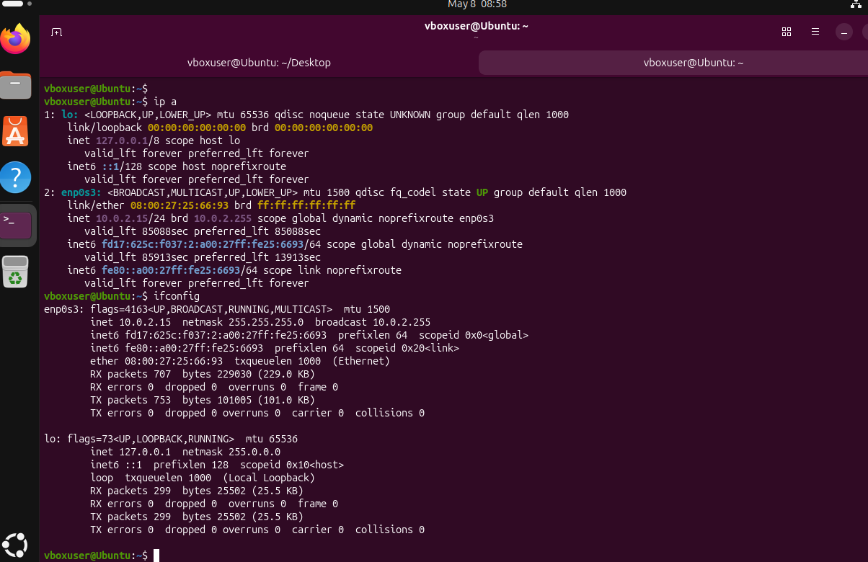
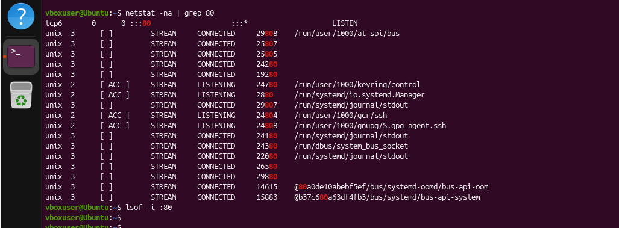
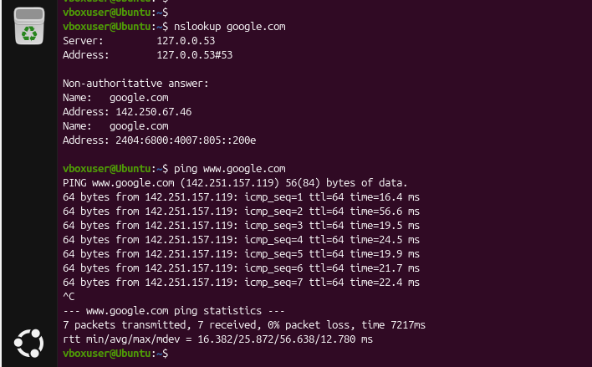
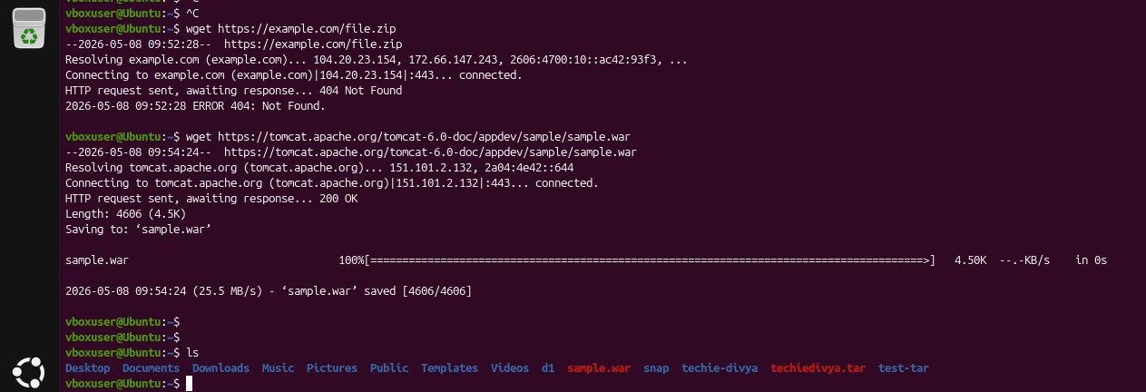
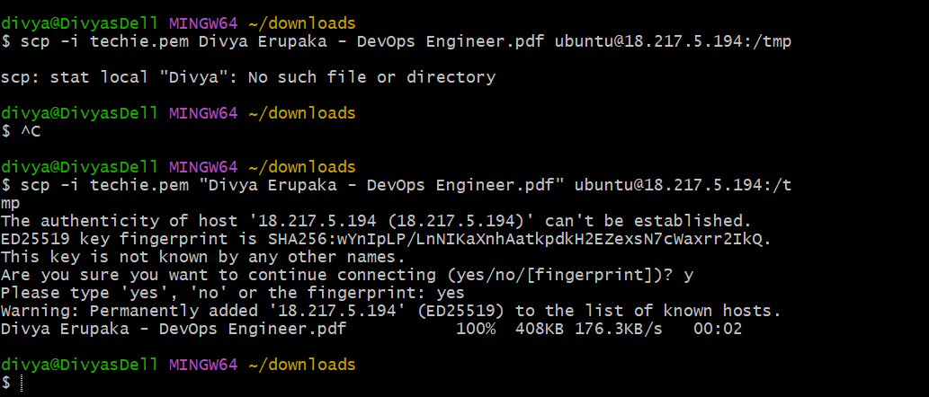
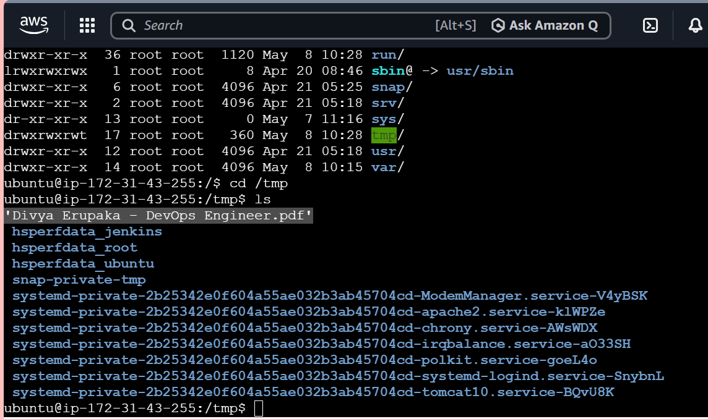
AWK is a text processing tool used to extract, filter, and manipulate data from files based on patterns and columns.
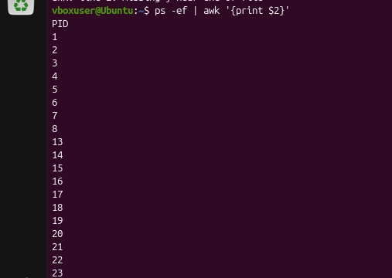

SED - sed is used to perform text manipulation (search, replace, delete, insert) in files and streams in an automated way without manually opening the file.